Assignment 4.2:

Create a sample dataset and implement the below Pig commands on the same dataset.

**Output:**

* **Logged into pig grunt shell locally. Created the sample employee dataset as Employee_details.txt**

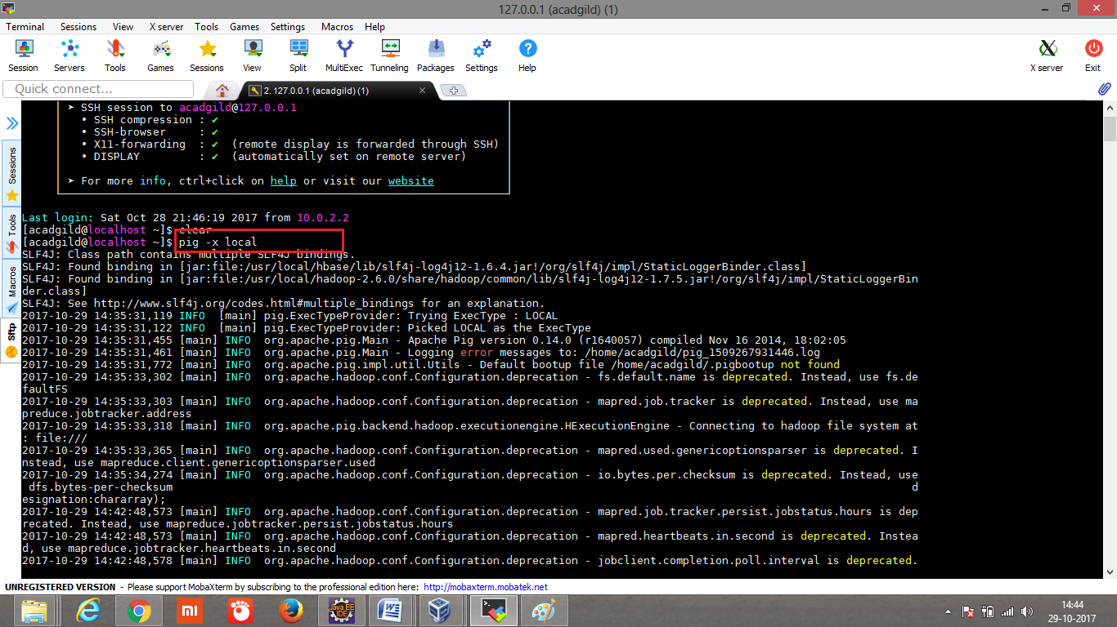

* Executed the below command to display the data in the dataset.

emp = LOAD ‘home/acadgild/employee_details.txt’ USING PigStorage(‘,’) As (employee_id: int, emp_name: chararray, emp_salary:int, emp_designation:chararray)

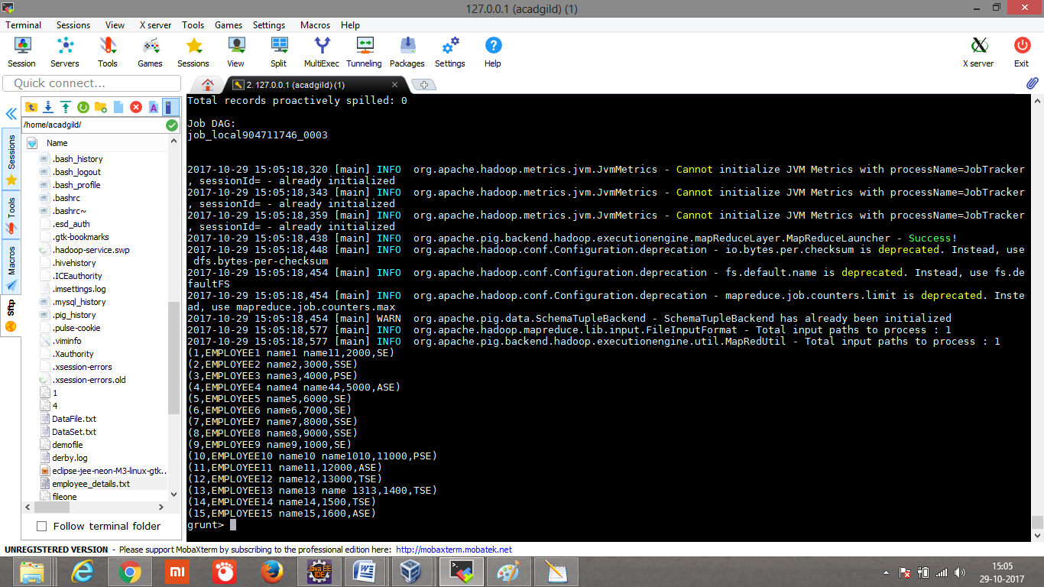

Describe emp to show the employee field datatype;

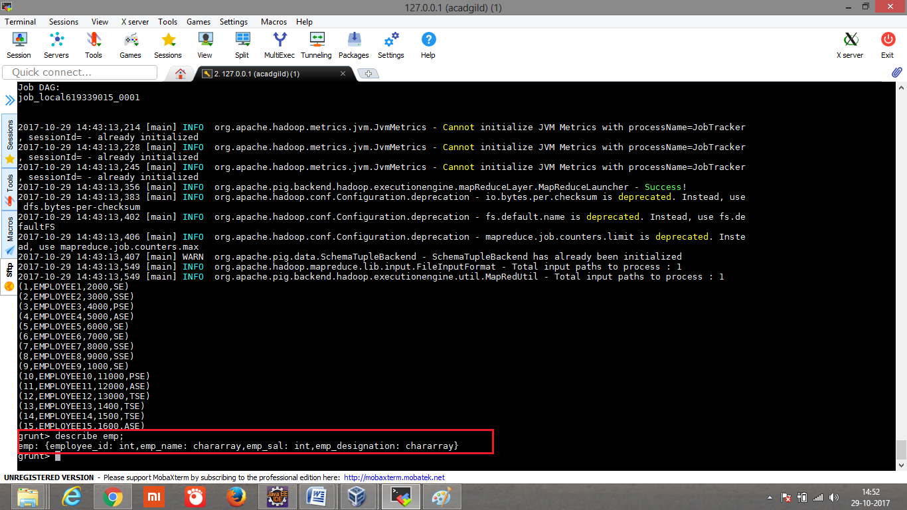

**CONCAT:** Concating employee name with label first Name for each employees.

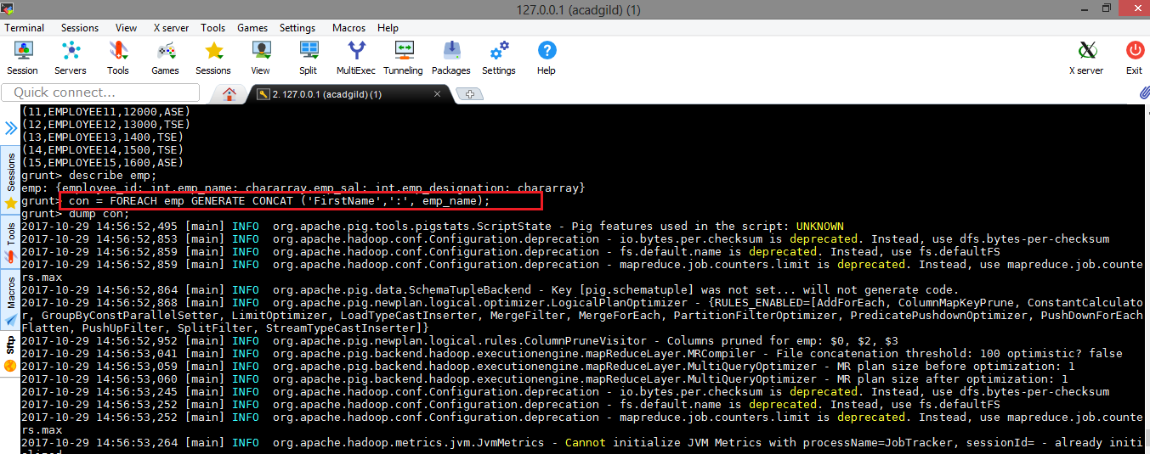

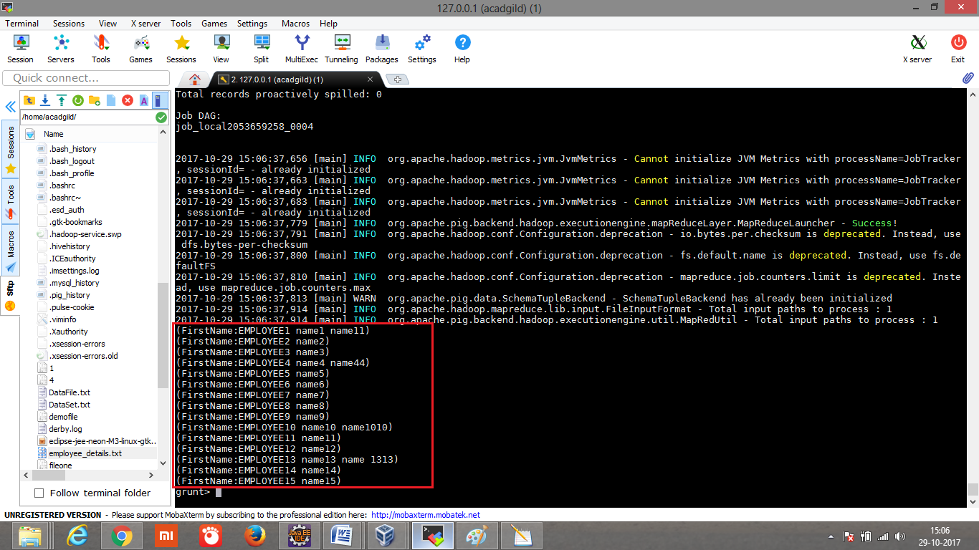

**TOKENIZE:** The TOKENIZE() function of Pig Latin is used to split a string (which contains a group of words) in a single tuple and returns a bag which contains the output of the split operation.

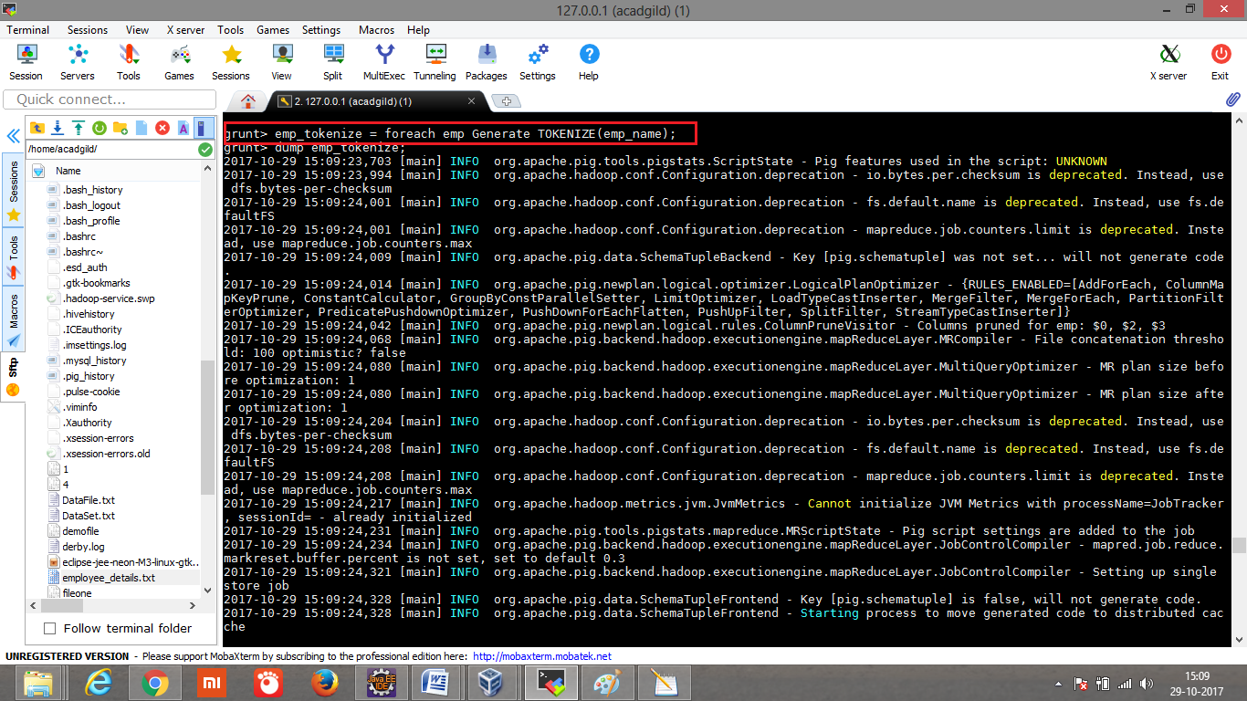

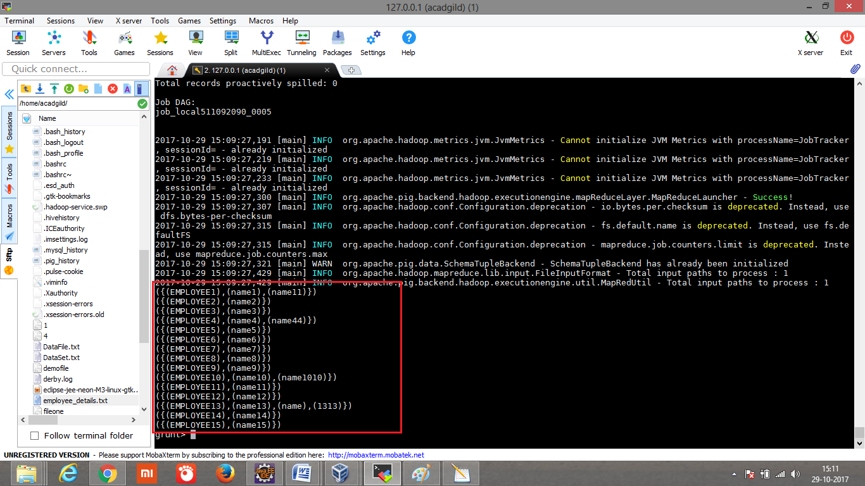

**SUM**:

Computes the sum of the numeric values in a single-column bag. SUM requires a preceding GROUP ALL statement for global sums and a GROUP BY statement for group sums.

1st will group the employee name, then will sum up the employee salary.

**Note: we modified the employee_details.txt and loaded again.**

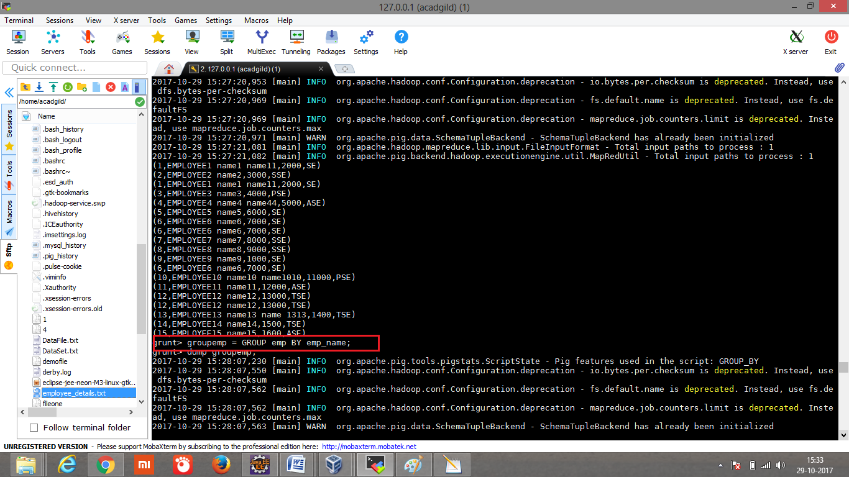

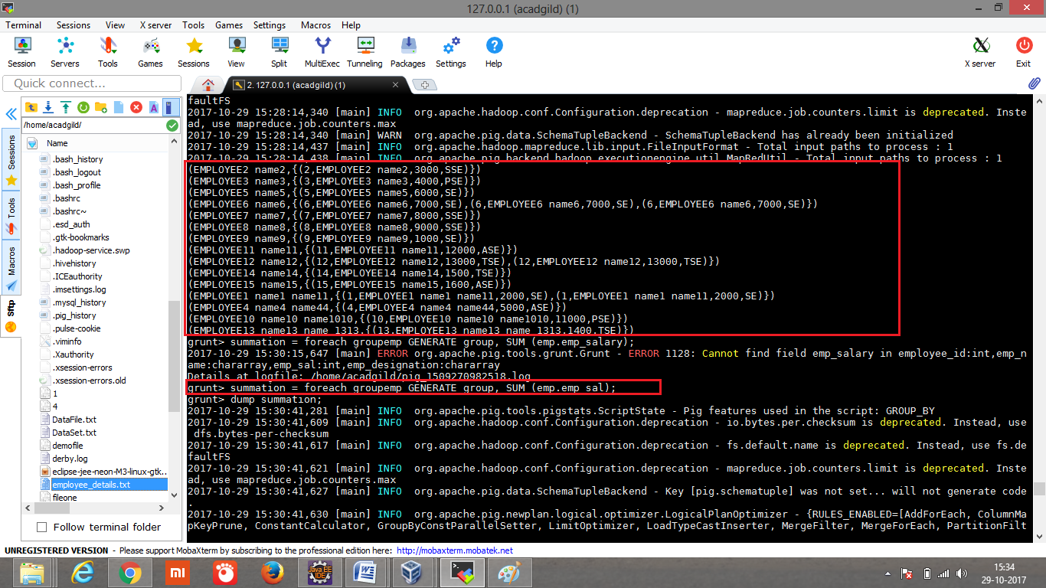

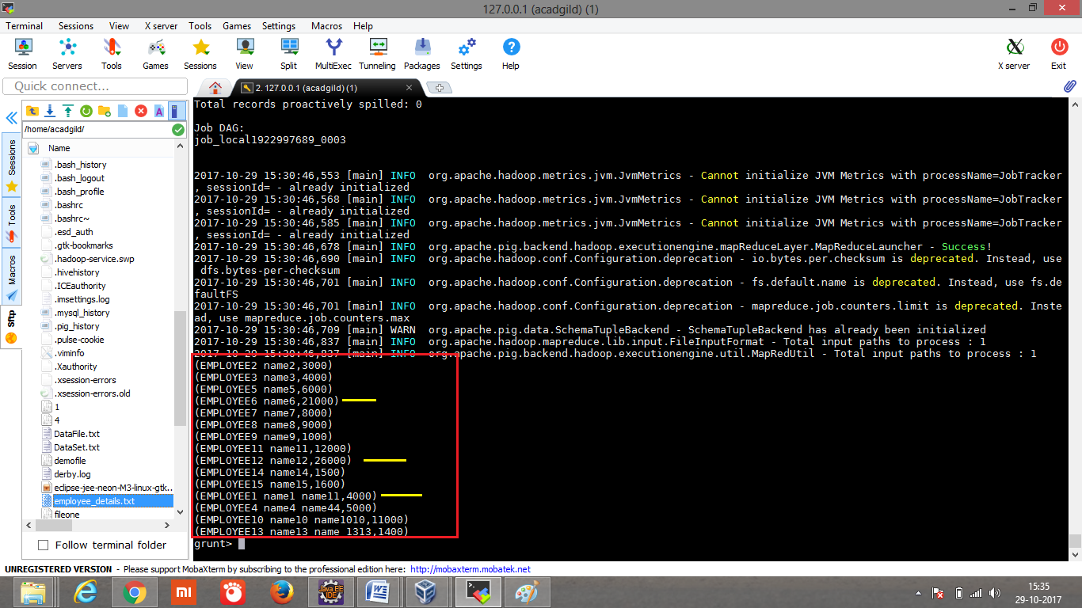

**MIN:**

Computes the minimum of the numeric values or chararrays in a single-column bag. MIN requires a preceding GROUP… ALL statement for global minimums and a GROUP … BY statement for group minimums.

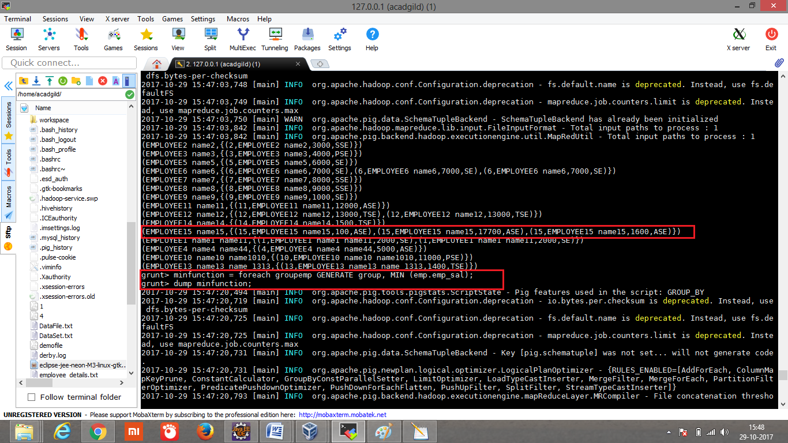

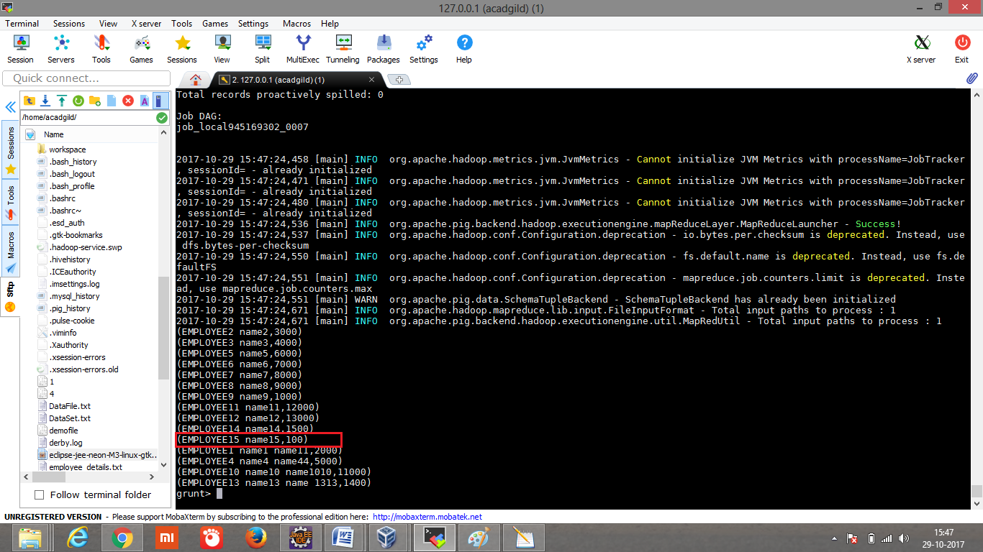

**Note: employee_details.txt modified and loaded again and dumped;**

**MAX:** shows the maximum salary of each employee in dataset

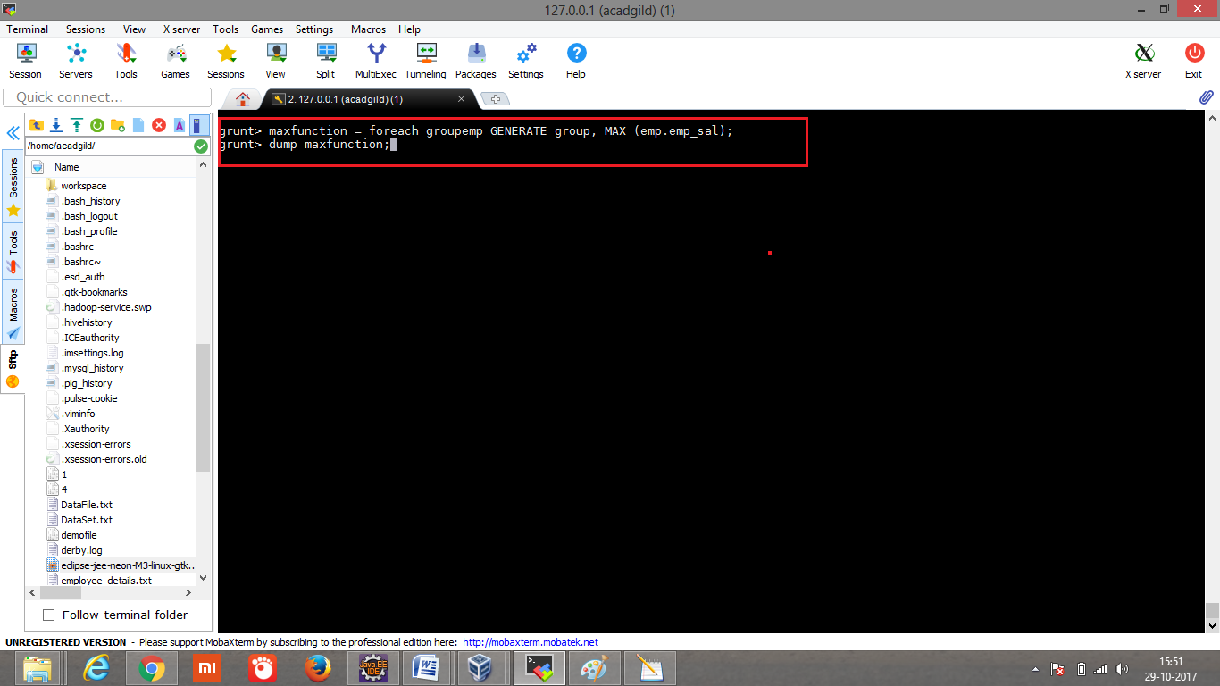

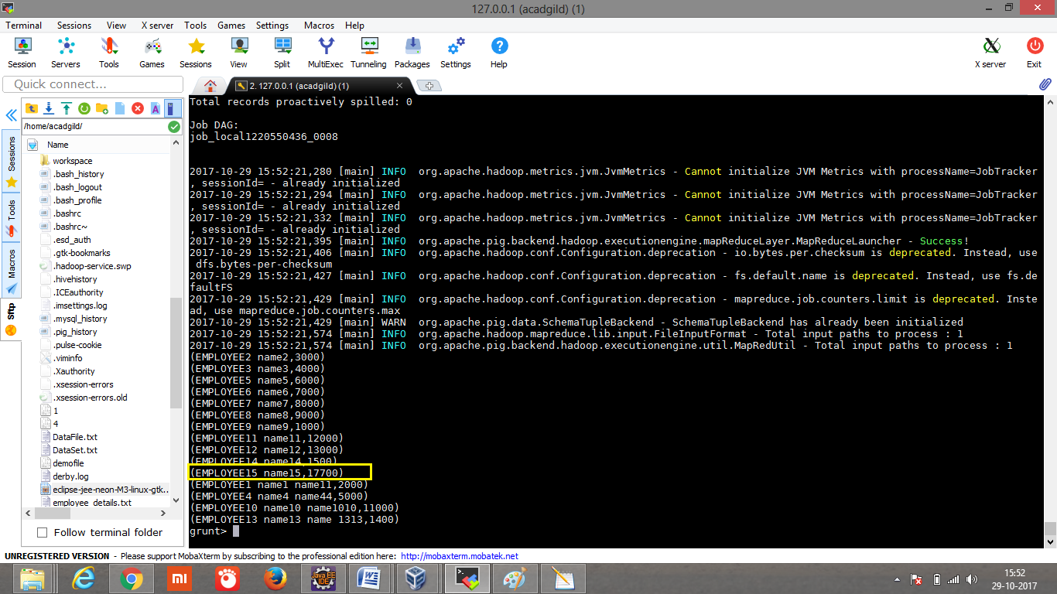

**LIMIT:** Shows the required number of records by limiting the size.

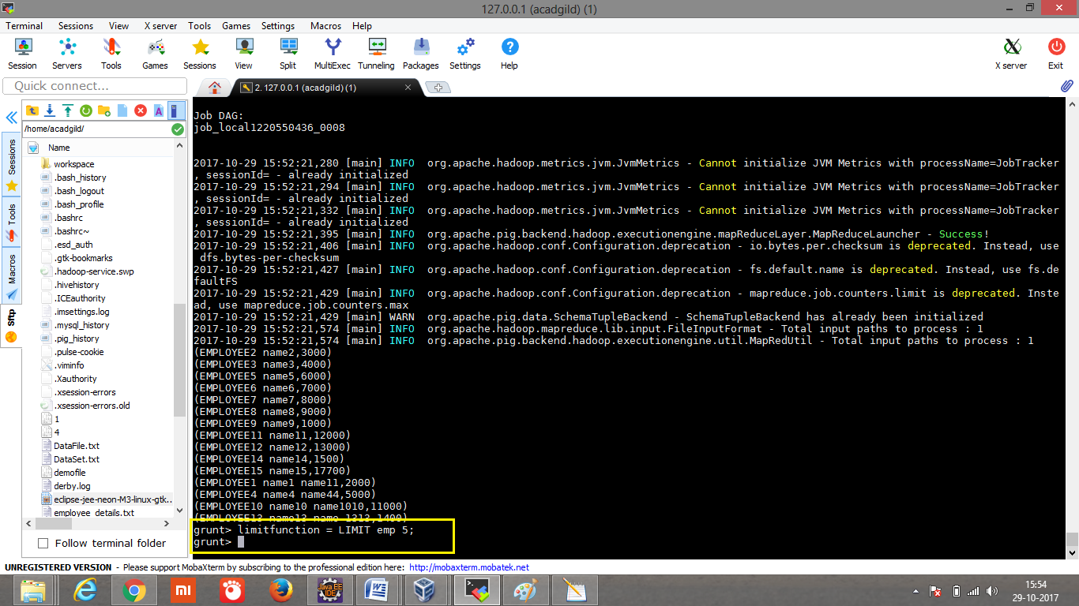

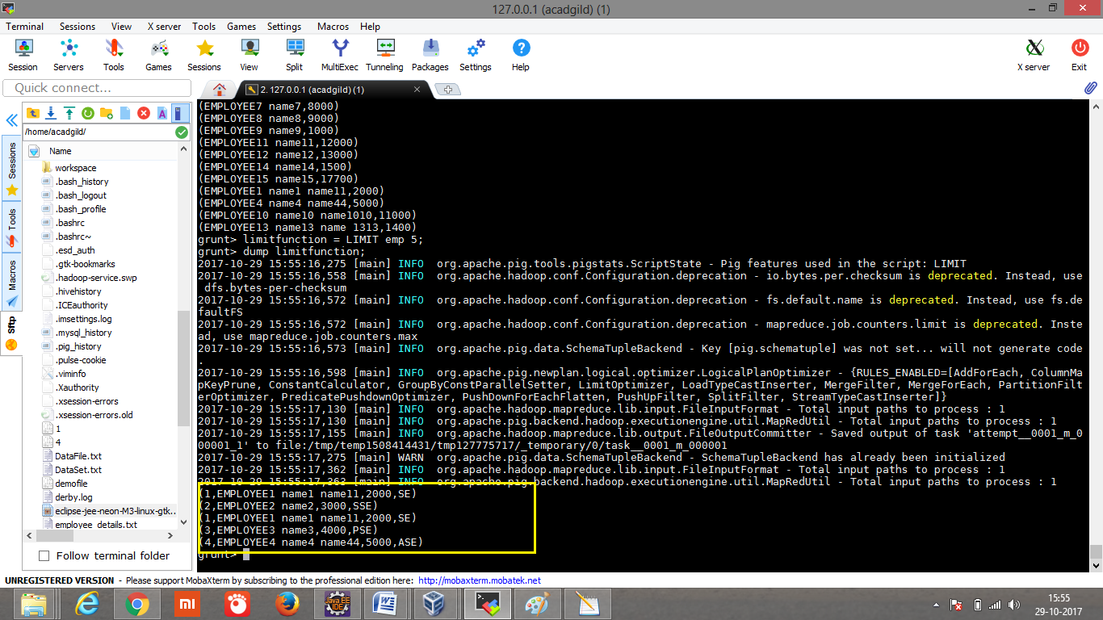

**STORE:** Stores the result data into external directory.

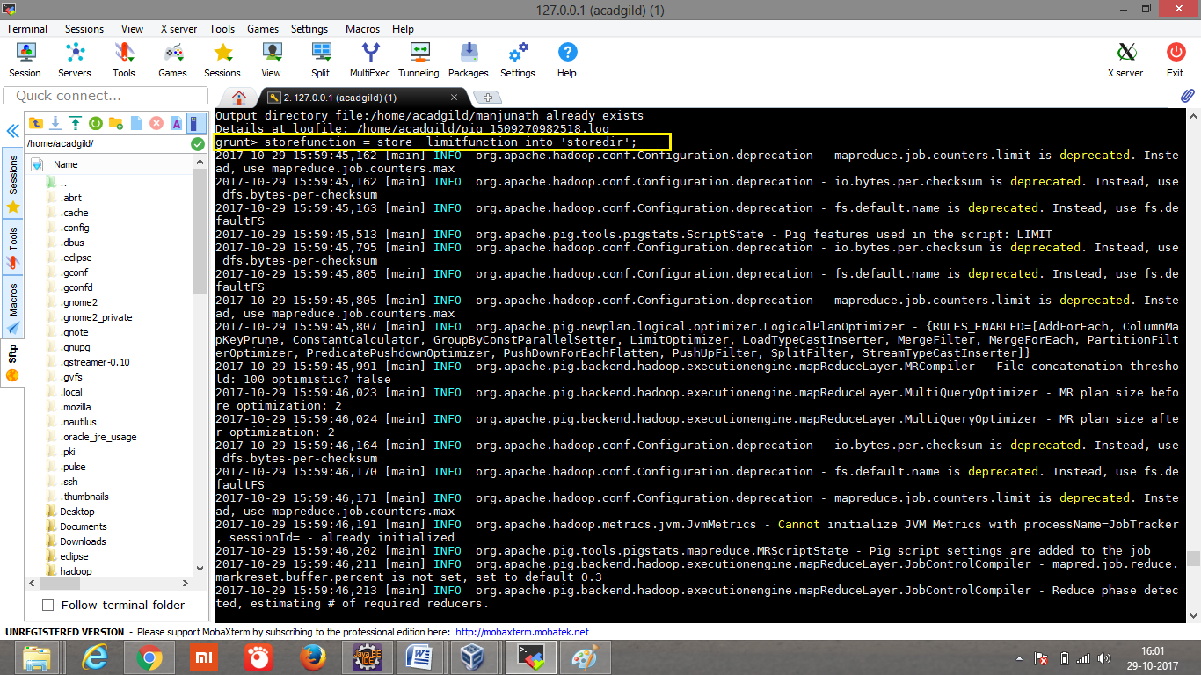

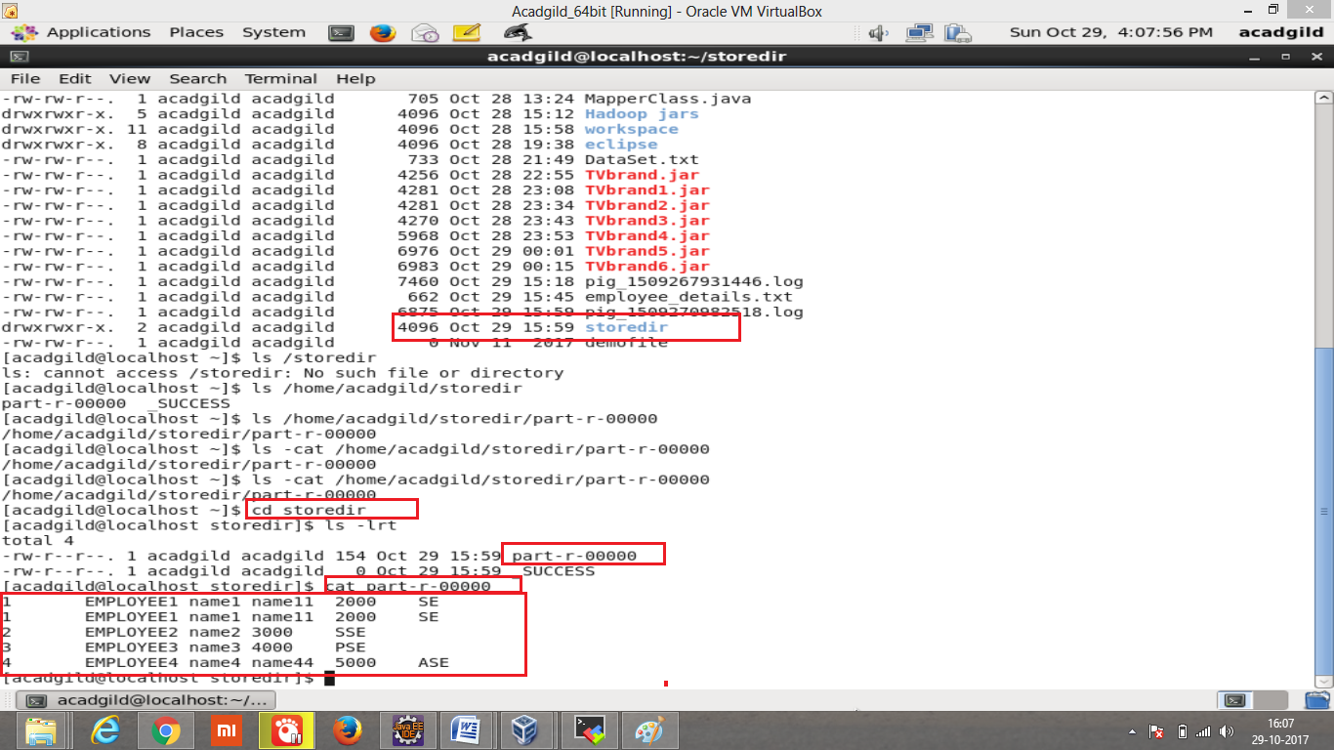

**DISTINCT: Results** distinct record in the dataset

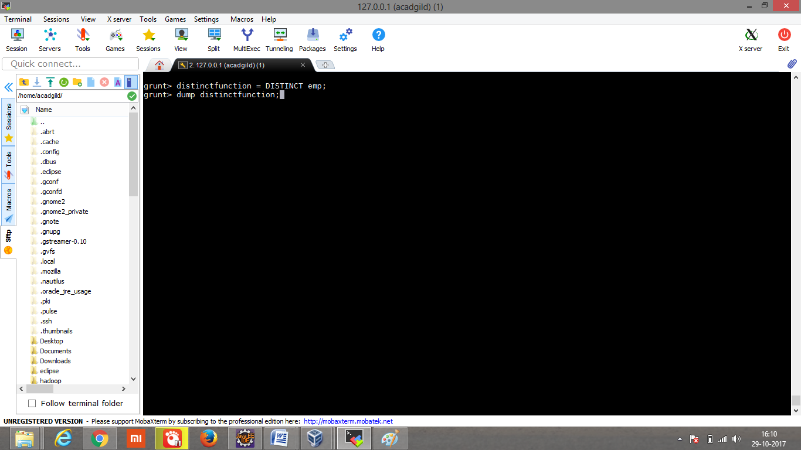

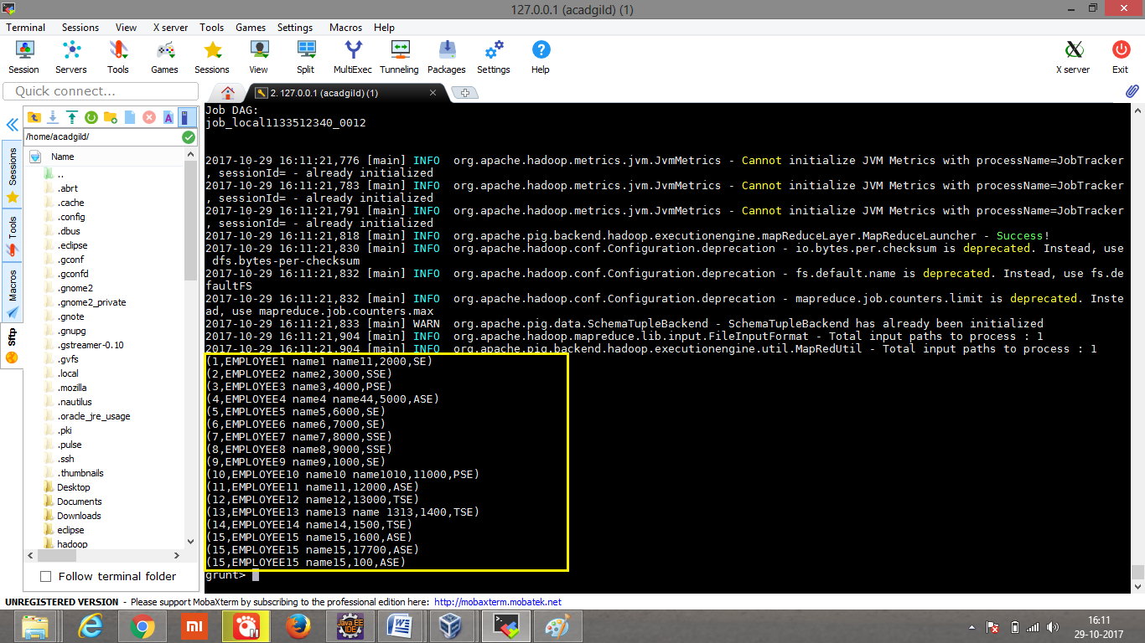

**FLATTEN:** Resultsthe column data

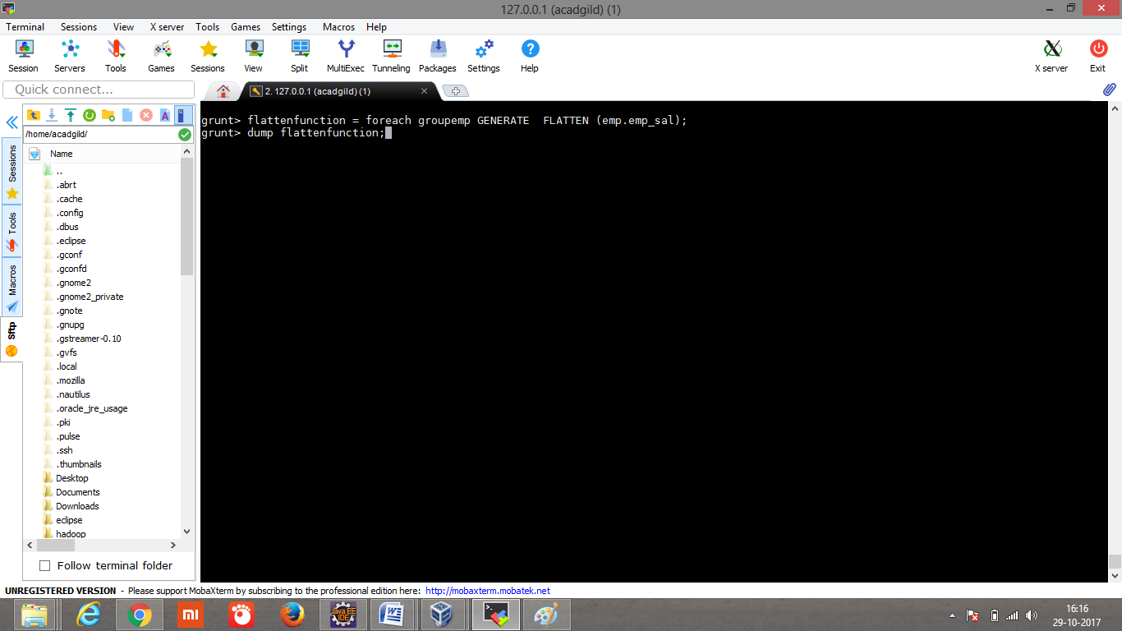

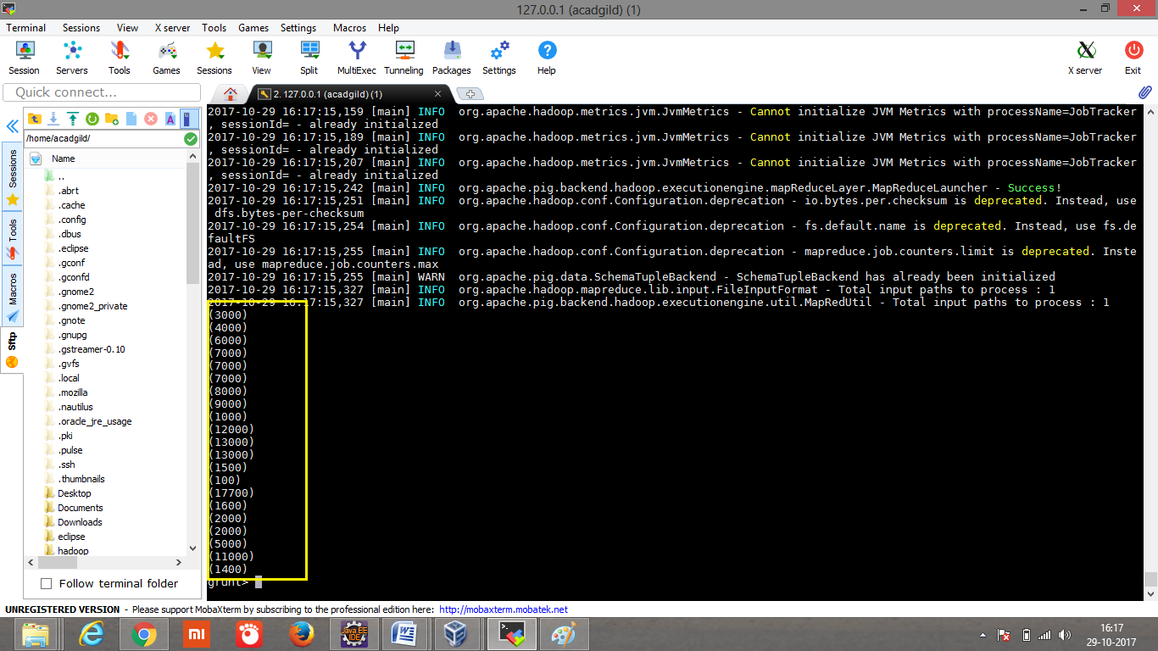

**ISEMPTY():** created one more dataset employee_detailsTwo.txt with similar data but few unique data.

